CS-23334 FUNDAMENTALS OF DATA SCIENCE
ASHWIN C 240701058

Experiment 13 Date: 16.10.2025

13. Hypothetical using T-Test

Aim:
To test whether the average IQ score of a sample of students differs significantly from a population mean IQ score of 100.

Description:
A statistical T-Test is conducted to determine if the average IQ score of a sample of students significantly differs from the population mean of 100.

Algorithm:

1. Null Hypothesis (H₀): The average IQ score of the sample is 100.
2. Alternative Hypothesis (H₁): The average IQ score of the sample is not 100.
3. Sample: Measure the IQ scores of 25 randomly selected students.
4. T-Test: Conduct a one-sample T-test to compare the sample mean to 100.
5. Decision Rule: Use a significance level of α = 0.05.

Code With Example:

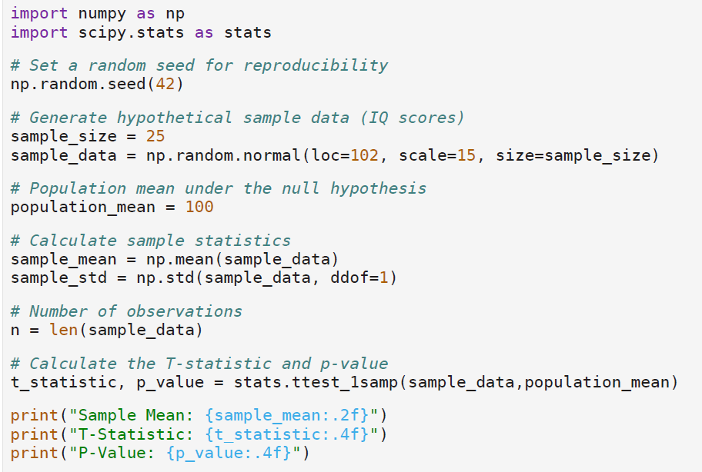

Output:

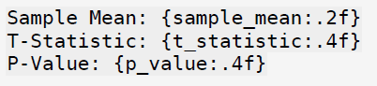

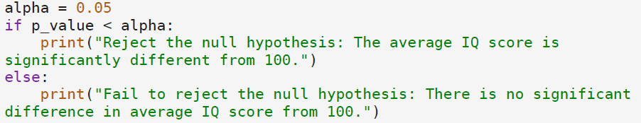

Output:

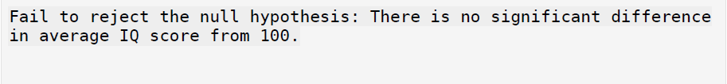

Result:

The Python program to test whether the average IQ score of a sample differs significantly from a population mean of 100 involves performing a one-sample T-Test that compares the sample mean to the population mean was executed

